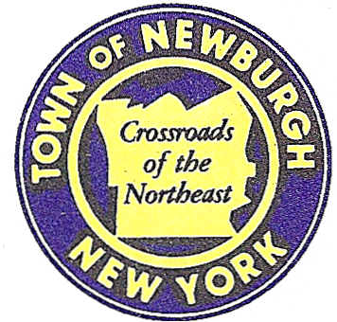

TOWN OF NEWBURGH
_______Crossroads of the Northeast __________________________
OLD TOWN HALL
308 GARDNERTOWN ROAD NEWBURGH, NEW YORK 12550

PLANNING BOARD
JOHN P. EWASUTYN, CHAIRMAN TELEPHONE 845-564-7804
FAX 845-564-7802
E-MAIL: planningboard@townofnewburgh.org

PLANNING BOARD AGENDA

SEPTEMBER 4, 2014

**PLEASE NOTE: The Planning Board Meeting will start at 7:00 P.M. and all Applicants/Representatives
are to be present at that time. The Meeting will be held in the Meeting Room of Town Hall, located at
1496 Route 300, Newburgh NY.**

- Mozo Properties (2014-14)  Mountain View Avenue  Section 4, Block 1, Lot 44  Rep: Lower Hudson Forestry Service  P.O. Box 756  Nyack, NY 10960 | PUBLIC HEARING  CLEARING & GRADING  TIMBER HARVEST
- Cassara Subdivision (2014-06)  442 Fostertown Road  Sec. 17; Blk.2; Lot 32.12  Zone: AR  Rep: Mercurio-Norton-Tarolli-Marshall  P.O. Box 166  Pine Bush, NY 12566 | PUBLIC HEARING  3-LOT SUBDIVISION
- Depew Energy (2014-09)  5182 Rt. 9W  Section 43, Block 5, Lots 41.2 & 42  Zone: B  Rep: Engineering Properties  71 Clinton Street  Montgomery, NY 12549 | AMENDED SITE PLAN
*WORK SESSION: Project Readiness Discussion scheduled for 6:00 p.m. in the Meeting Room
of Town Hall on Thursday, September 4, 2014*

